I remember with gratitude the RSM family, those olden days which took me not alone through academics of nursing education but lessons for life too.

One of the most valuable lessons I learned at RSM was the power of empathy. The precise clinical trainings gave me opportunities to get aligned with the patients, experiencing their trauma and vulnerability which goes hand in hand with any ailment or injury. Here I learned, beyond the diagnosis or prognosis, to attend each patient with due respect and confidence. Those lessons are in me even today, guiding me while I interact with patients and their families.

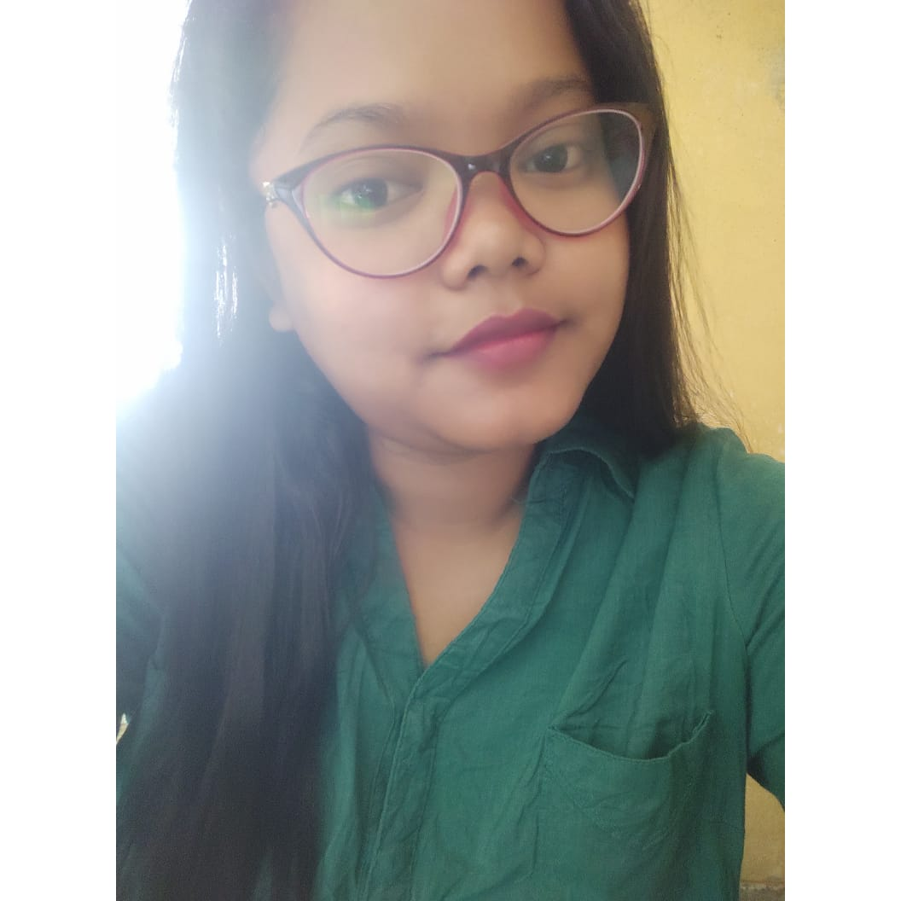

BATCH

Gamterachi G Momin

Staffnurse

Baghmara Civil Hospital, South Garo Hills Meghalaya

Pulina Devi Rabha.

Community Health Officer

Bhaitbari CHC under Thakimagre HWC

West Garo hills

.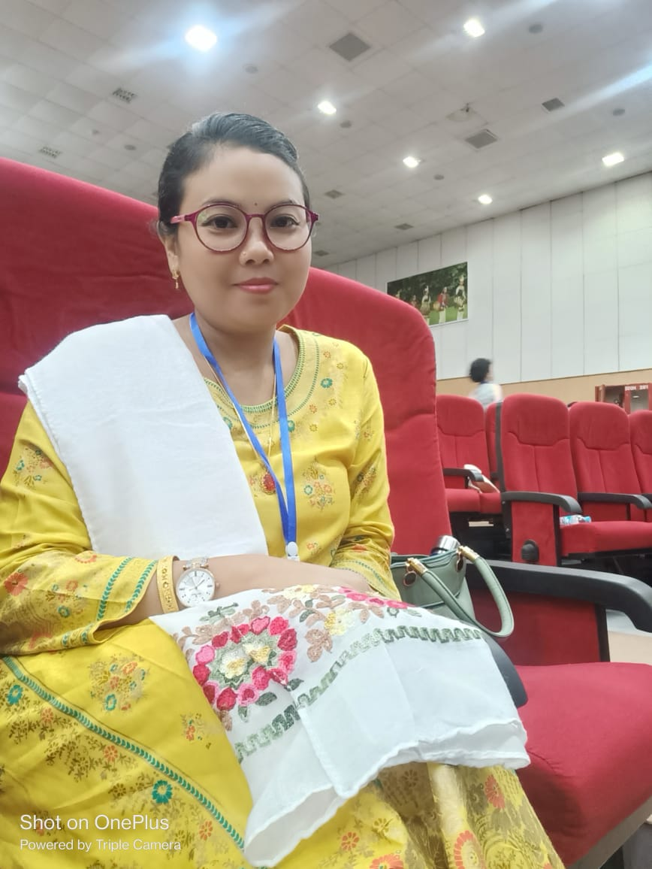

As an RSM school of nursing alumni, I am proud of what I am today. The values acquired, the experiences gained and friendships established along with academics at RSM nurtured me into a matured professional. Days at RSM were not a mere stepping stone to a career instead was a journey that prepared me for a life of service, compassion, and healing and as I move ahead, the lessons I had learned from here always remind me of the nobility of my profession.

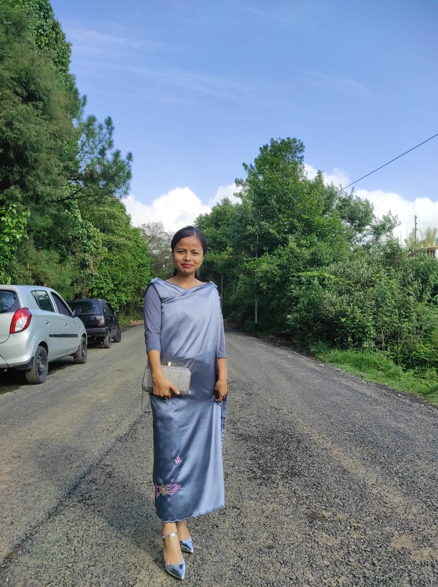

As I look back on my journey from RSM nursing school to where I am today, I am filled with gratitude for the opportunities that came across my way and the lives I had been privileged to touch. Nursing is not just a career, it is a calling, a vocation, a way of life. And as a proud RSM alumni, I am honored to be part of a profession dedicated to making a difference in the lives of others.

AibianghunTangsong

Former Staff nurse at Holy Cross Hospital Tura.

Nursing tutor in RSM school of Nursing Tura

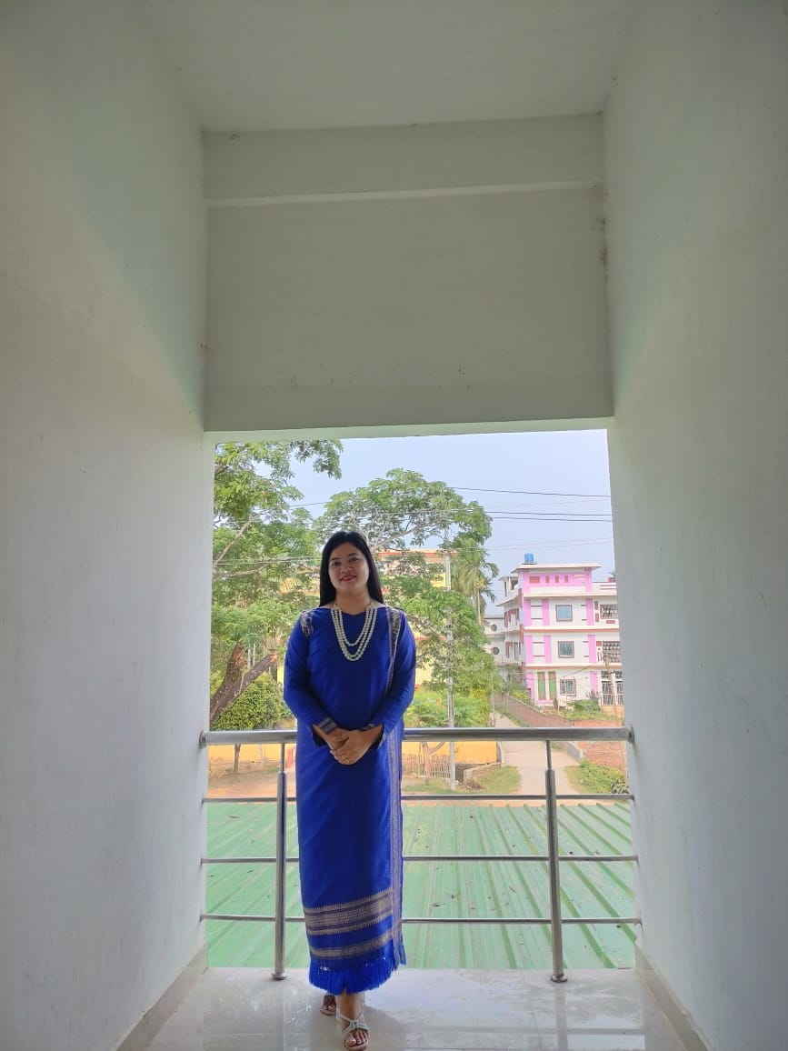Ms. Jenovena Marshiangbai ( 5th batch)

It is an honour to share my journey as an alumni of RSM School of nursing. My days here not only shaped my career but also moulded me into the person I am today. Days at RSM was not just about textbooks and exams; but was a journey of self-discovery and personal growth. I learned the importance of resilience in the face of challenges, whether it was mastering complex medical concepts or juggling multiple responsibilities form here.

The serene environment, my teachers, classmates and friends, helped me in realizing my passion for nursing, tiding over anything and everything.

Faculty

Rani institute of Nursing . Guwahati

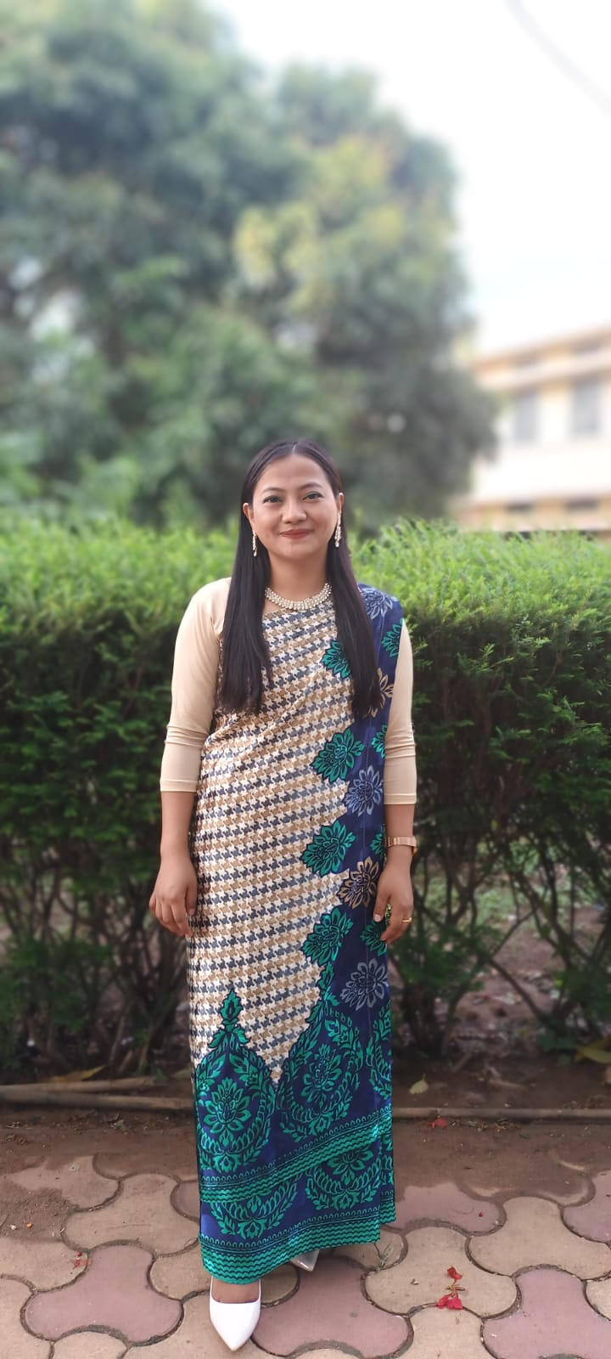

When I think of RSM school of nursing, I remember with gratitude and love all my beloveds who introduced me to the nursing profession. One of the most memorable aspects of my education at RSM was the opportunity I got, to work directly with patients during clinical rotations. Assisting and comforting patients in their most vulnerable moments, taught me something new about compassion, empathy, and the importance of human connection in healthcare. I embarked on my nursing career with a sense of purpose and determination stricly based on the values inculcated in me during those days. Nursing is a dynamic field, constantly evolving with new technologies, treatments, and challenges. As a lifelong learner, I have embraced opportunities for continuing education and professional development, eager to stay at the forefront of healthcare practices and advancements.

Miss. Steffi

Staff Nurse Pynursla CHC under NHM

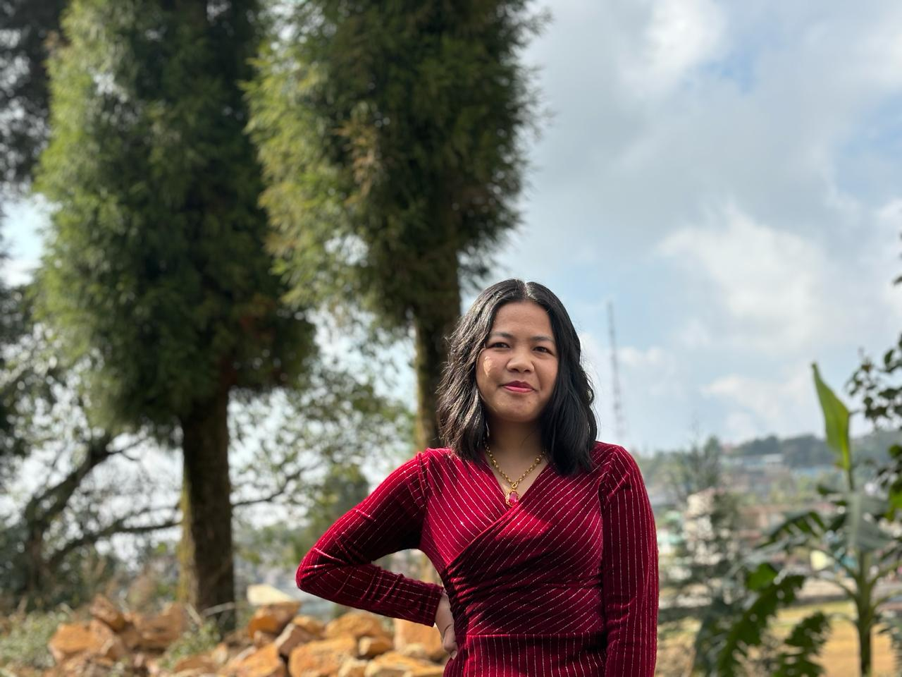

RSM school of nursing has given me tremendous opportunity for me, I am ever grateful to my teachers, my peers and Holy cross hospital where I learned my skill. As I reflect on my journey from nursing school to where I am today, a rush of memories floods my mind. Little did I know then the profound impact that this journey would have on me, both personally and professionally, My time at RSM showered upon me a host of experiences, the late nights in the lab, the clinical rotations, the challenges alongside etc, shaped me into the healthcare professional I am today. It wasn't easy; there were moments of doubt and exhaustion, but there were also moments of triumph and joy that made it all worthwhile. I thank almighty for all the success of my life.

Lawanhunsyngkrem

Staff Nurse, Pynursla CHC under NHM